Rectangle rule result: 3214.369451817829 Mpc

Trapezoidal rule result: 3214. 279443866709 Mpc

Simpson's rule result: 3214.2794434491766 Mpc

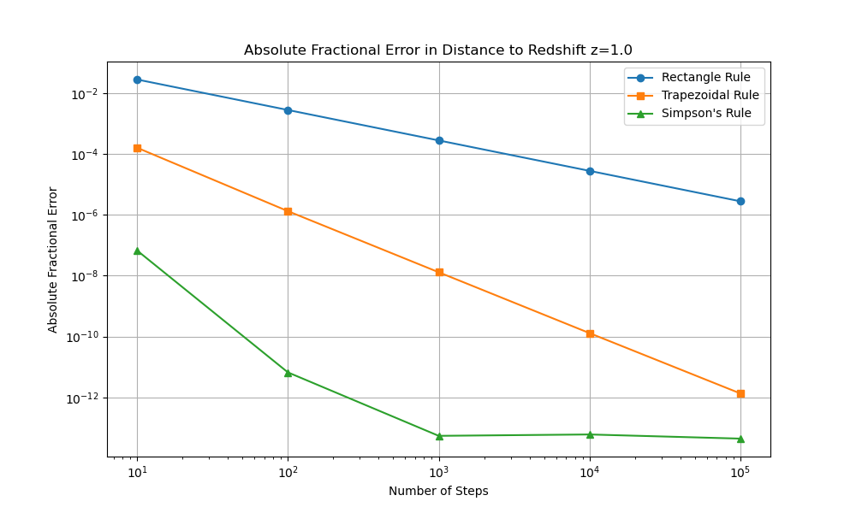

An assumption has been made that the number of steps = 10^6 is close enough to be considered as an accurate true value. So, the denominator of the fractional error is the distance when number of steps equals to 10^6. In the plot, Rectangle Rule and Trapezoidal Rule seem like linear functions, whereas Simpson’s rule has been already converged to a very small value. So, even if we take more evaluations of the function (more precise values), it will not make any surprise (2 Linear functions and 1 converging function). For this reason, the method I would recommend for this calculation is Simpson’s method and I have decided to include up to 10^5.

Good target accuracy: 10^(-5) = 1/10^5. 3

Typical size of a galaxy is between 3000 to 300000 light-years. Let’s assume that the size of a galaxy A is 30000 light-years. The value is roughly 0.01 Mpc, which gives value of 3.1\*10^(-5) for absolute fractional error (0.01/3214). If you're measuring the distance of the galaxy, the precision that is smaller than the size of the galaxy is pointless because the distance from the Earth to that galaxy is ambiguous. So, 10^(-5) would be roughly a good target accuracy.



